## Reports/Inventory Reports/ Drug Movement/Comp Drug Movement

Request:

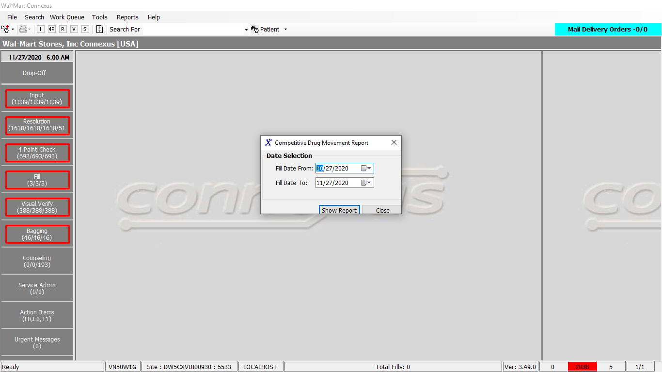

Response

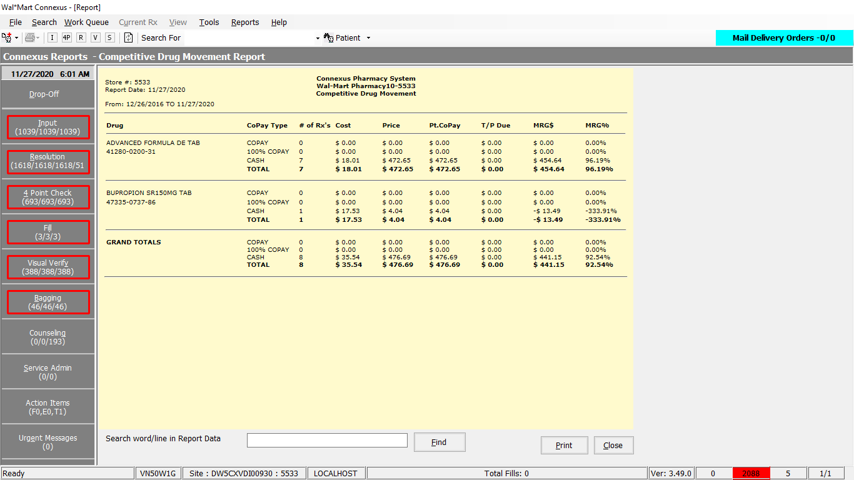

Queries:

1. Friend Const GetCompDrugMovementSelect1 As String = " Select distinct pi.mds_fam_id, pp.short_name drug, pi.ndc_nbr NDC from rx_fill rf, rx_fill_item rfi, pharmacy_offering:pharmacy_product pp, pharmacy_offering: pharmacy_item pi Where rf.rx_fill_id = rfi.rx_fill_id AND rf.comp_price_amt > 0 AND rf.rph_of_rec_userid is not NULL AND rf.rph_of_rec_userid <> '' AND rfi.item_mds_fam_id = pi.mds_fam_id AND pi.product_mds_fam_id = pp.product_mds_fam_id AND rf.fill_date BETWEEN ? AND ? AND rf.status_code = ? ORDER BY drug "

2. Friend Const GetCompDrugMovementSelect2 As String = "Select pi.mds_fam_id, pp.short_name drug, pi.ndc_nbr NDC, count(distinct rx.rx_nbr) rxs, sum(rfi.actual_cost_amt) ACQ, sum(rf.expected_sale_amt) Price, sum(rf.patient_due_amt) copay, sum(rsd.txn_amt) netdue from rx, rx_fill rf, rx_fill_item rfi, rx_sale_detail rsd, pharmacy_offering:pharmacy_product pp, pharmacy_offering: pharmacy_item pi Where rx.rx_id = rf.rx_id AND rx.rx_version_seq_nbr = rf.rx_version_seq_nbr AND rf.rx_fill_id = rfi.rx_fill_id AND rf.rph_of_rec_userid is not NULL AND rf.rph_of_rec_userid <> '' AND rfi.item_mds_fam_id = pi.mds_fam_id AND pi.product_mds_fam_id = pp.product_mds_fam_id AND rf.fill_date BETWEEN ? AND ? AND rf.third_party_ind = 'Y' AND rf.patient_due_amt > 0 AND rf.comp_price_amt > 0 AND rf.rx_fill_id = rsd.rx_fill_id AND rsd.txn_amt > 0 AND rsd.txn_type_code = ? AND rsd.status_code IN (?, ?) AND rf.status_code = ? Group by 1, 2, 3"

3. Friend Const GetCompDrugMovementSelect3 As String = " Select pi.mds_fam_id, pp.short_name drug, pi.ndc_nbr NDC, count(distinct rx.rx_nbr) rxs, sum(rfi.actual_cost_amt) ACQ, sum(rf.expected_sale_amt) Price, sum(rf.patient_due_amt) copay, sum(rsd.txn_amt) netdue from rx, rx_fill rf, rx_fill_item rfi, rx_sale_detail rsd, pharmacy_offering:pharmacy_product pp, pharmacy_offering: pharmacy_item pi Where rx.rx_id = rf.rx_id AND rx.rx_version_seq_nbr = rf.rx_version_seq_nbr AND rf.rph_of_rec_userid is not NULL AND rf.rph_of_rec_userid <> '' AND rf.rx_fill_id = rfi.rx_fill_id AND rf.rph_of_rec_userid is not NULL AND rf.rph_of_rec_userid <> '' AND rfi.item_seq_nbr = 1 AND rfi.item_mds_fam_id = pi.mds_fam_id AND pi.product_mds_fam_id = pp.product_mds_fam_id AND rf.fill_date BETWEEN ? AND ? AND rf.third_party_ind = 'Y' AND rf.patient_due_amt > 0 AND rf.comp_price_amt > 0 AND rf.status_code = ? AND rf.rx_fill_id = rsd.rx_fill_id AND rsd.txn_amt = 0 AND rsd.txn_type_code = ? AND rsd.status_code IN (?, ?) Group by 1, 2, 3"

4. Friend Const GetCompDrugMovementSelect4 As String = " Select pi.mds_fam_id, pp.short_name drug, pi.ndc_nbr NDC, count(distinct rx.rx_nbr) rxs, sum(rfi.actual_cost_amt) ACQ, sum(rf.expected_sale_amt) Price, sum(rf.patient_due_amt) copay from rx, rx_fill rf, rx_fill_item rfi, pharmacy_offering:pharmacy_product pp, pharmacy_offering: pharmacy_item pi Where rx.rx_id = rf.rx_id AND rx.rx_version_seq_nbr = rf.rx_version_seq_nbr AND rf.rx_fill_id = rfi.rx_fill_id AND rf.rph_of_rec_userid is not NULL AND rf.rph_of_rec_userid <> '' AND rfi.item_seq_nbr = 1 AND rfi.item_mds_fam_id = pi.mds_fam_id AND rf.status_code = ? AND rf.comp_price_amt > 0 AND pi.product_mds_fam_id = pp.product_mds_fam_id AND rf.fill_date BETWEEN ? AND ? AND rf.third_party_ind = 'N' AND rf.patient_due_amt > 0 Group by 1, 2, 3"

Dal:

Public Function GetCompDrugMovement(ByVal siteId As Integer,

ByVal fromDate As DateTime, ByVal toDate As DateTime) _

As GetCompDrugMovementInfoBE Implements IReportDAL.GetCompDrugMovement

Dim sqlDrugList As String

Dim sqlCopayList As String

Dim sql100CopayList As String

Dim sqlCash As String

Dim hundredCopayListInfoBEList As New List(Of CopayListInfoBE)

Dim cashInfoBEList As New List(Of CopayListInfoBE)

Dim getCompDrugMovementInfoBE As New GetCompDrugMovementInfoBE

Dim drugInfoBEList As New List(Of DrugInfoBE)

Dim copayListInfoBEList As New List(Of CopayListInfoBE)

Dim filteredCopayListInfoBEList As New List(Of CopayListInfoBE)

Dim filteredHundredCopayInfoBEList As New List(Of CopayListInfoBE)

Dim filteredCashInfoBEList As New List(Of CopayListInfoBE)

Dim paramList As New List(Of DbParameter)

'Start the method trace

Using (New Tracer(ConnexusCommonConstants.ConnexusTracer))

sqlDrugList = ReportQueries.GetCompDrugMovementSelect1

paramList.Add(ParameterHelper.BuildParameter("fillDate", DbType.Date, fromDate))

paramList.Add(ParameterHelper.BuildParameter("fillDate", DbType.Date, toDate))

paramList.Add(ParameterHelper.BuildParameter("statusCode", DbType.Int16,

FillStatusCodes.FillActive))

Using dataReaderDrugs As IDataReader = ExecuteReader(DatabaseEnum.rx21c,

siteId, sqlDrugList, paramList)

Dim drugInfoBE As DrugInfoBE

While dataReaderDrugs.Read()

drugInfoBE = New DrugInfoBE

If Not dataReaderDrugs.IsDBNull(dataReaderDrugs.GetOrdinal("drug")) Then

drugInfoBE.Drug = CStr(dataReaderDrugs("drug")).Trim

End If

If Not dataReaderDrugs.IsDBNull(dataReaderDrugs.GetOrdinal("mds_fam_id")) Then

drugInfoBE.MdsFamId = CInt(dataReaderDrugs("mds_fam_id"))

End If

If Not dataReaderDrugs.IsDBNull(dataReaderDrugs.GetOrdinal("NDC")) Then

drugInfoBE.Ndc = CStr(dataReaderDrugs("NDC")).Trim

End If

drugInfoBEList.Add(drugInfoBE)

End While

End Using

sqlCopayList = ReportQueries.GetCompDrugMovementSelect2

paramList.Clear()

paramList.Add(ParameterHelper.BuildParameter("fillDate", DbType.Date, fromDate))

paramList.Add(ParameterHelper.BuildParameter("fillDate", DbType.Date, toDate))

paramList.Add(ParameterHelper.BuildParameter("txnTypeCode", DbType.Int16,

TxnTypeCode.PrimaryTP))

paramList.Add(ParameterHelper.BuildParameter("statusCode", DbType.Int16,

StatusCodes.ClaimSub))

paramList.Add(ParameterHelper.BuildParameter("statusCode", DbType.Int16,

StatusCodes.DownTime))

paramList.Add(ParameterHelper.BuildParameter("statusCode", DbType.Int16,

FillStatusCodes.FillActive))

Using dataReader As IDataReader = ExecuteReader(DatabaseEnum.rx21c, siteId,

sqlCopayList, paramList)

Dim drugInfoBE As DrugInfoBE

Dim copayListInfoBE As CopayListInfoBE

While dataReader.Read

copayListInfoBE = New CopayListInfoBE

drugInfoBE = New DrugInfoBE

If Not dataReader.IsDBNull(dataReader.GetOrdinal("ACQ")) Then

copayListInfoBE.Acq = CDec(dataReader("ACQ"))

End If

If Not dataReader.IsDBNull(dataReader.GetOrdinal("copay")) Then

copayListInfoBE.Copay = CDec(dataReader("copay"))

End If

If Not dataReader.IsDBNull(dataReader.GetOrdinal("netdue")) Then

copayListInfoBE.NetDue = CDec(dataReader("netdue"))

End If

If Not dataReader.IsDBNull(dataReader.GetOrdinal("Price")) Then

copayListInfoBE.Price = CDec(dataReader("Price"))

End If

If Not dataReader.IsDBNull(dataReader.GetOrdinal("rxs")) Then

copayListInfoBE.Rxs = CInt(dataReader("rxs"))

End If

If Not dataReader.IsDBNull(dataReader.GetOrdinal("drug")) Then

drugInfoBE.Drug = CStr(dataReader("drug")).Trim

End If

If Not dataReader.IsDBNull(dataReader.GetOrdinal("mds_fam_id")) Then

drugInfoBE.MdsFamId = CInt(dataReader("mds_fam_id"))

End If

If Not dataReader.IsDBNull(dataReader.GetOrdinal("NDC")) Then

drugInfoBE.Ndc = CStr(dataReader("NDC")).Trim

End If

copayListInfoBE.DrugInfo = drugInfoBE

copayListInfoBEList.Add(copayListInfoBE)

End While

End Using

sql100CopayList = ReportQueries.GetCompDrugMovementSelect3

paramList.Clear()

paramList.Add(ParameterHelper.BuildParameter("fillDate", DbType.Date, fromDate))

paramList.Add(ParameterHelper.BuildParameter("fillDate", DbType.Date, toDate))

paramList.Add(ParameterHelper.BuildParameter("statusCode", DbType.Int16,

FillStatusCodes.FillActive))

paramList.Add(ParameterHelper.BuildParameter("txnTypeCode", DbType.Int16,

TxnTypeCode.PrimaryTP))

paramList.Add(ParameterHelper.BuildParameter("statusCode", DbType.Int16,

StatusCodes.ClaimSub))

paramList.Add(ParameterHelper.BuildParameter("statusCode", DbType.Int16,

StatusCodes.DownTime))

Using dataReader As IDataReader = ExecuteReader(DatabaseEnum.rx21c,

siteId, sql100CopayList, paramList)

Dim drugInfoBE As DrugInfoBE

Dim copayListInfoBE As CopayListInfoBE

While dataReader.Read

copayListInfoBE = New CopayListInfoBE

drugInfoBE = New DrugInfoBE

If Not dataReader.IsDBNull(dataReader.GetOrdinal("ACQ")) Then

copayListInfoBE.Acq = CDec(dataReader("ACQ"))

End If

If Not dataReader.IsDBNull(dataReader.GetOrdinal("copay")) Then

copayListInfoBE.Copay = CDec(dataReader("copay"))

End If

If Not dataReader.IsDBNull(dataReader.GetOrdinal("netdue")) Then

copayListInfoBE.NetDue = CDec(dataReader("netdue"))

End If

If Not dataReader.IsDBNull(dataReader.GetOrdinal("Price")) Then

copayListInfoBE.Price = CDec(dataReader("Price"))

End If

If Not dataReader.IsDBNull(dataReader.GetOrdinal("rxs")) Then

copayListInfoBE.Rxs = CInt(dataReader("rxs"))

End If

If Not dataReader.IsDBNull(dataReader.GetOrdinal("drug")) Then

drugInfoBE.Drug = CStr(dataReader("drug")).Trim

End If

If Not dataReader.IsDBNull(dataReader.GetOrdinal("mds_fam_id")) Then

drugInfoBE.MdsFamId = CInt(dataReader("mds_fam_id"))

End If

If Not dataReader.IsDBNull(dataReader.GetOrdinal("NDC")) Then

drugInfoBE.Ndc = CStr(dataReader("NDC")).Trim

End If

copayListInfoBE.DrugInfo = drugInfoBE

hundredCopayListInfoBEList.Add(copayListInfoBE)

End While

End Using

sqlCash = ReportQueries.GetCompDrugMovementSelect4

paramList.Clear()

paramList.Add(ParameterHelper.BuildParameter("statusCode", DbType.Int16,

FillStatusCodes.FillActive))

paramList.Add(ParameterHelper.BuildParameter("fillDate", DbType.Date,

fromDate))

paramList.Add(ParameterHelper.BuildParameter("fillDate", DbType.Date,

toDate))

Using dataReader As IDataReader = ExecuteReader(DatabaseEnum.rx21c, siteId,

sqlCash, paramList)

Dim drugInfoBE As DrugInfoBE

Dim copayListInfoBE As CopayListInfoBE

While dataReader.Read

copayListInfoBE = New CopayListInfoBE

drugInfoBE = New DrugInfoBE

If Not dataReader.IsDBNull(dataReader.GetOrdinal("ACQ")) Then

copayListInfoBE.Acq = CDec(dataReader("ACQ"))

End If

If Not dataReader.IsDBNull(dataReader.GetOrdinal("copay")) Then

copayListInfoBE.Copay = CDec(dataReader("copay"))

End If

If Not dataReader.IsDBNull(dataReader.GetOrdinal("Price")) Then

copayListInfoBE.Price = CDec(dataReader("Price"))

End If

If Not dataReader.IsDBNull(dataReader.GetOrdinal("rxs")) Then

copayListInfoBE.Rxs = CInt(dataReader("rxs"))

End If

If Not dataReader.IsDBNull(dataReader.GetOrdinal("drug")) Then

drugInfoBE.Drug = CStr(dataReader("drug")).Trim

End If

If Not dataReader.IsDBNull(dataReader.GetOrdinal("mds_fam_id")) Then

drugInfoBE.MdsFamId = CInt(dataReader("mds_fam_id"))

End If

If Not dataReader.IsDBNull(dataReader.GetOrdinal("NDC")) Then

drugInfoBE.Ndc = CStr(dataReader("NDC")).Trim

End If

copayListInfoBE.DrugInfo = drugInfoBE

cashInfoBEList.Add(copayListInfoBE)

End While

End Using

'Check if the drugInfoBEList is not null then add it to the GetCompDrugMovementBE

If Not getCompDrugMovementInfoBE Is Nothing Then

Dim drugId As Integer

Dim recordFound As Boolean

getCompDrugMovementInfoBE.DrugInfo = drugInfoBEList

For Each singleDrugInfoDE In drugInfoBEList

drugId = singleDrugInfoDE.MdsFamId

recordFound = False

If Not copayListInfoBEList Is Nothing And copayListInfoBEList.Count > 0 Then

For Each singleCopayListInfoBE In copayListInfoBEList

If singleCopayListInfoBE.DrugInfo.MdsFamId = drugId Then

filteredCopayListInfoBEList.Add(singleCopayListInfoBE)

recordFound = True

End If

Next

'If no record with Id found,add nothing

If Not recordFound Then

Dim singleCopay As CopayListInfoBE = Nothing

filteredCopayListInfoBEList.Add(singleCopay)

recordFound = False

End If

Else

Dim singleCopay As CopayListInfoBE = Nothing

filteredCopayListInfoBEList.Add(singleCopay)

End If

getCompDrugMovementInfoBE.CoPayListInfo = filteredCopayListInfoBEList

If Not hundredCopayListInfoBEList Is Nothing And

hundredCopayListInfoBEList.Count > 0 Then

recordFound = False

For Each singleCopayListInfoBE In hundredCopayListInfoBEList

If singleCopayListInfoBE.DrugInfo.MdsFamId = drugId Then

filteredHundredCopayInfoBEList.Add(singleCopayListInfoBE)

recordFound = True

End If

Next

'If no record with Id found,add nothing

If Not recordFound Then

Dim hundredCopay As CopayListInfoBE = Nothing

filteredHundredCopayInfoBEList.Add(hundredCopay)

recordFound = False

End If

Else

Dim hundredCopay As CopayListInfoBE = Nothing

filteredHundredCopayInfoBEList.Add(hundredCopay)

End If

getCompDrugMovementInfoBE.HundredCopayListInfoBEList = filteredHundredCopayInfoBEList

If Not cashInfoBEList Is Nothing And cashInfoBEList.Count > 0 Then

recordFound = False

For Each singleCopayListInfoBE In cashInfoBEList

If singleCopayListInfoBE.DrugInfo.MdsFamId = drugId Then

filteredCashInfoBEList.Add(singleCopayListInfoBE)

recordFound = True

End If

Next

'If no record with Id found,add nothing

If Not recordFound Then

Dim cash As CopayListInfoBE = Nothing

filteredCashInfoBEList.Add(cash)

recordFound = False

End If

Else

Dim cash As CopayListInfoBE = Nothing

filteredCashInfoBEList.Add(cash)

End If

getCompDrugMovementInfoBE.CashInfoBEList = filteredCashInfoBEList

Next

End If

Return getCompDrugMovementInfoBE

End Using

End Function